**Software Requirements Specification**

for

**Family Photo Album**

**Authors:**

Alina Momin,

Thomas Wang,

Wes Robinson,

Huzaifa Zia,

Rostam Boroumand Rad,

Zyad Ahmed

UMBC

9/22/2022

**1. Introduction** **3**

1.1 Purpose 3

1.2 Intended Audience and Reading Suggestions 3

1.3 Product Scope 3

**2. System Features** **3**

2.1 System Feature 1: Display Images 4

2.2 System Feature 2: : Display selected image over the gallery 5

**3. Other Nonfunctional Requirements** **5**

3.1 Performance Requirements 5

3.2 Safety Requirements 5

3.3 Security Requirements 6

3.4 Software Quality Attributes 6

3.5 Business Rules 6

**4. Other Requirements** **6**

**Revision History**

| **Name** | **Date** | **Reason For Changes** | **Version** |
| --- | --- | --- | --- |
| Version 1 | 9/22/22 | Initial SRS Document | 1.0 |
| Version 1.1 | 11/1/2022 | Final SRS Document edit | 1.1 |

# **1.** **Introduction**

## **1.1** **Purpose**

The purpose of this document is to provide requirements for the Gizmos system. The scope of this document includes the system requirements that will be designed by the team, the functional requirement that the Gizmos system must satisfy and the tests that will verify that the system functions according to the requirements.

## **1.2** **Intended Audience and Reading Suggestions**

This document breaks down the systems life cycle as created by the project managers that is to be implemented and tested by the developers. The intended user audience for the system is anyone wanting to organize their photo albums.

This document gives the system overview and scope of the Gizmos project. It includes the System Boundary Diagram System functional requirements, System non-functional requirements and Testing requirements.

## **1.3** **Product Scope**

The scope of this document is to create a product to design a system that aids users managing their photo albums and allow them to curate it with various features.

# **2.** **System Features**

2.0.1: System Boundary Diagram (SBD)

The system boundary diagram illustrates the internal and external systems for the Gizmo system. There are two main systems illustrated below. The Graphical interface is the central hub that users will interact with. Here they will have login options for the user. After login, the user is able to transfer files and access their photo gallery. All of the user information and photo metadata lives in the database and can be viewable in the user accessible photo gallery.

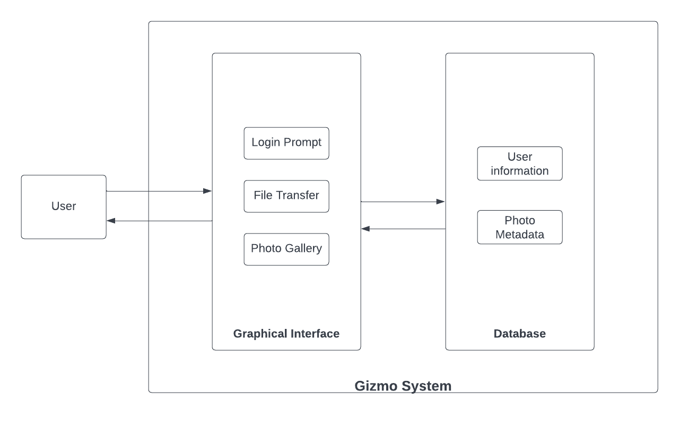

Diagram 1: System Boundary Diagram

The user will interact with the Gizmo system through the graphical interface. They will be able to create an account and log in to access their gallery of photos. The database and graphical interface will communicate. The database will hold information about the user account, the photos and the associated metadata with each photo.

The UI of the photo album will follow the Graphical Interface UI.

The directory of user photo albums will be displayed on the left. The photos within the selected album will be displayed in the middle and the associated metadata will be displayed on the right. The user will be able to tag photos with words. Users will also be able to sort the gallery display by date, color, and tags. The user will also be able to add albums, add photos to albums as well as delete photos from albums.

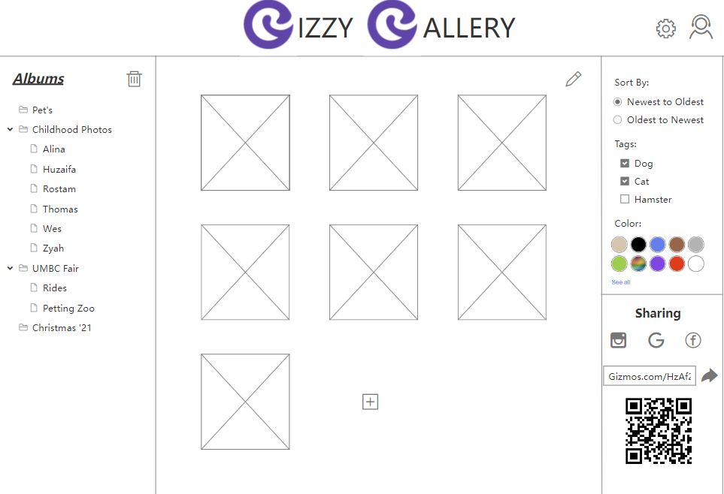

Diagram 2: Graphical Interface UI

## **2.1** **Upload Images**

Description: This feature allows the user to upload images from the desired device to albums in the gallery.

2.1.1 Users are able to log into their account and upload images to albums in the gallery.

## **2.2 Export Images**

Description: This feature allows the user to export images back to the user storage.

2.1.1 User export images to hard drive or storage location. Medium priority, the product can still run without moving images to the hard drive.

2.2.2 User export a group of images to hard drive or storage location

2.2.3 User exports a group of images to cloud based storage. Medium Priority, the .Benefit 9

## **2.3** **Display Images**

Description: This feature allows the user to see a groups of images.

2.3.1 Visualizing the photos is an essential feature of the Gizzy Gallery.

2.3.2 Once the user logs in, the program will display images. The user will be able to visualize the gallery as shown in Diagram 2: Graphical Interface UI.

2.3.3 The images will be loaded with different encoding from the URL or filename which will display the images to the UI.

## **2.4 Display selected image over the gallery**

Description: This feature allows the user to view a selected photo from the gallery.

2.4.1. The gallery will display a volume of images and the user should be able to select an image to view.

2.4.2.The image selected will be filtered using metadata based on time, tags and color.

2.4.3.The user will be able to examine a photo by selecting it and viewing the metadata associated with the image.

**2.5 Ability to add tags**

Description: This feature allows the user to add tags for sorting, locating, and organizing the photos in the album.

2.5.1 The user will be able to tag a photo with a string of text.

2.5.2 There will be functionality that allows the user to append and edit text to the tags associated with the fields.

2.5.3 The tags will be stored in the database and used to filter through images in the gallery when the user is sorting the gallery for an image.

**2.6 Sort images from Metadata**

Description: This feature allows for images to be sorted with the metadata associated with each image.

2.6.1 The images are able to be sorted by date, location, tags and color.

**2.7 Login/ Sign-up implementation**

Description: This feature allows for users to create an account and login to access the Gizzy Gallery.

2.6.1 The user will be able to create a new account or login with an existing account.

2.6.2 The account will be confirmed via a google account.

2.6.3 When creating an account the user will include an email, password, password confirmation and a security question.

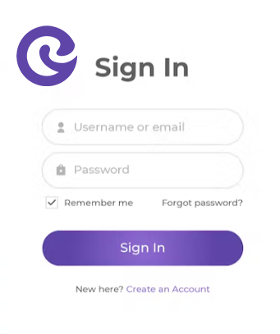

# **3.** **Other Nonfunctional Requirements**

## **3.1** **Performance Requirements**

3.1.1 Image Streaming:

The system will implement image streaming. Photos will be streamed in a subsequence in runtime to load a high volume of images in an album. Memory management is required to increase speed in image streaming.

3.1.2 Image Processing

Image processing would allow extensive ways of processing pictures. This would be implemented using processing algorithms that would also allow for getting information such as average or maximum image color and for identifying faces with machine learning.

## **3.2** **Safety and Security Requirements**

Safety requirements will primarily focus on user privacy. Authentication via a google account will be required to verify user login. Prevention of data leaks will need to be considered along with data storage and deletion.

When working with user data, it is necessary to ensure the security of user uploads. Photos uploaded by users will be visible only to the user unless otherwise shared with another user. User tags marked hidden will not be displayed in the gallery.

**3.3** **Software Quality Attributes**

The software quality will prioritize the user experience. Features are implemented to be appealing to our users such as an easy to navigate UI, ability to switch between a light/dark mode UI, and a fast runtime. Additional features that would be beneficial to our customers would include the option to delete images.

## **3.4** **Business Rules**

The product would consider safety and security for users. The functional requirements specified are focused on enhancing the user experience with the Gizzy Gallery. Our team consists of six members who are focused on making this a viable and functional product.

wanting to keel over and succumb to the lo